1. Diberikan notasi

(2 * 5) + (10 / 2) – 7^2

1. Konversi ke prefix

|  |  |  |  |
| --- | --- | --- | --- |
| Symbol | Stack | Prefix String | Operation |
| 2 |  | 2 | add(2) |
| ^ | ^ | 2 | Push(^) |
| 7 | ^ | 7 2 | Add(7) |
| - | - | ^ 7 2 | Pop(^), push(-) |
| ) | - ) | ^ 7 2 | Push()) |
| 2 | - ) | 2 ^ 7 2 | Add(2) |
| / | - ) / | 2 ^ 7 2 | Push(/) |
| 10 | - ) / | 10 2 ^ 7 2 | Add(10) |
| ( | - | / 10 2 ^ 7 2 | Pop(/) |
| + | - + | / 10 2 ^ 7 2 | Push(+) |
| ) | - + ) | / 10 2 ^ 7 2 | Push()) |
| 5 | - + ) | 5 / 10 2 ^ 7 2 | Add(5) |
| * | - + ) * | 5 / 10 2 ^ 7 2 | Push(*) |
| 2 | - + ) * | 2 5 / 10 2 ^ 7 2 | Add(2) |
| ( | - + | * 2 5 / 10 2 ^ 7 2 | Pop(*) |
|  |  | - + * 2 5 / 10 2 ^ 7 2 | Pop(+), pop(-) |

1. Menghitung hasil notasi prefix

|  |  |  |
| --- | --- | --- |
| Symbol | Stack | Operation |
| 2 | 2 | Push(2) |
| 7 | 2 7 | Push(7) |
| ^ | 49 | Pop(7), pop(2), push(7 ^ 2) |
| 2 | 49 2 | Push(2) |
| 10 | 49 2 10 | Push(10) |
| / | 49 5 | Pop(10), pop(2), push(10 / 2) |
| 5 | 49 5 5 | Push(5) |
| 2 | 49 5 5 2 | Push(2) |
| * | 49 5 10 | Pop(2), pop(5), push(2 * 5) |
| + | 49 15 | Pop(10), pop(5), push(10 + 5) |
| - | -34 | Pop(15), pop(49), push(15 - 49) |

1. Diberikan BST

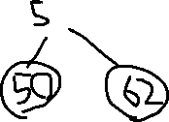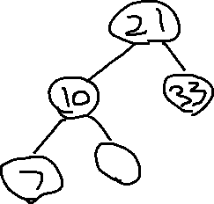

1. Delete 47
2. Bukan complete binary tree karena pada level terakhir nodenya tidak terisi dari kiri ke kanan, ada yang bolong.